Cryptographic hash functions are designed to be one-way and deterministic. According to our learning, SHA-1 normally produces a 160-bit digest but for the purpose of this project we have truncated the digest to n bits and experiment by measuring the difficulty of both a collision attack and a preimage attack. The purpose of this experiment is to compare the theoretical expectations with the actual results and is performed by repeating these trials using a SHA-1 truncation wrapper. We expect the collision attack to cost 2^(n/2) and the preimage attack to cost 2^n.
A SHA-1 wrapper was implemented to first hash an input string using SHA-1. It then truncates the digest to n bits and returns the truncated digest as an integer. The project includes testing eight bit sizes, being 8, 10, 12, 14, 18, 20, and 22. By using these bit sizes we get a foundational dataset that we can measure while also ensuring that the simulated attacks do not take hours to complete. The collision attacks were performed using a random message that was generated for each bit size until two messages were able to produce the same truncated hash. The preimage attack took a fixed message m_1 that was hashed. Random messages were then generated until one matched its truncated hash. For both the collision attack and the preimage attack 50 trials were performed for each bit size, measuring the iteration count and results were stored in a csv reflecting the type of attack, number of bits, the sample number and the iteration.
Depicted below is the graph of the collision attack, comparing the theoretical results with the mean actual results of each bit size. All bit sizes closely follow the theoretical expectations, confirming that the behavior of the experiment followed the expected birthday paradox behavior. Digging deeper into the results, there were some small variances. In bit size 8, many trials found collisions quickly due to the search space being small. At larger bit sizes such as 20 and 22, the variance was much smaller indicated that as the space grew randomness averaged out and the results became more stable.
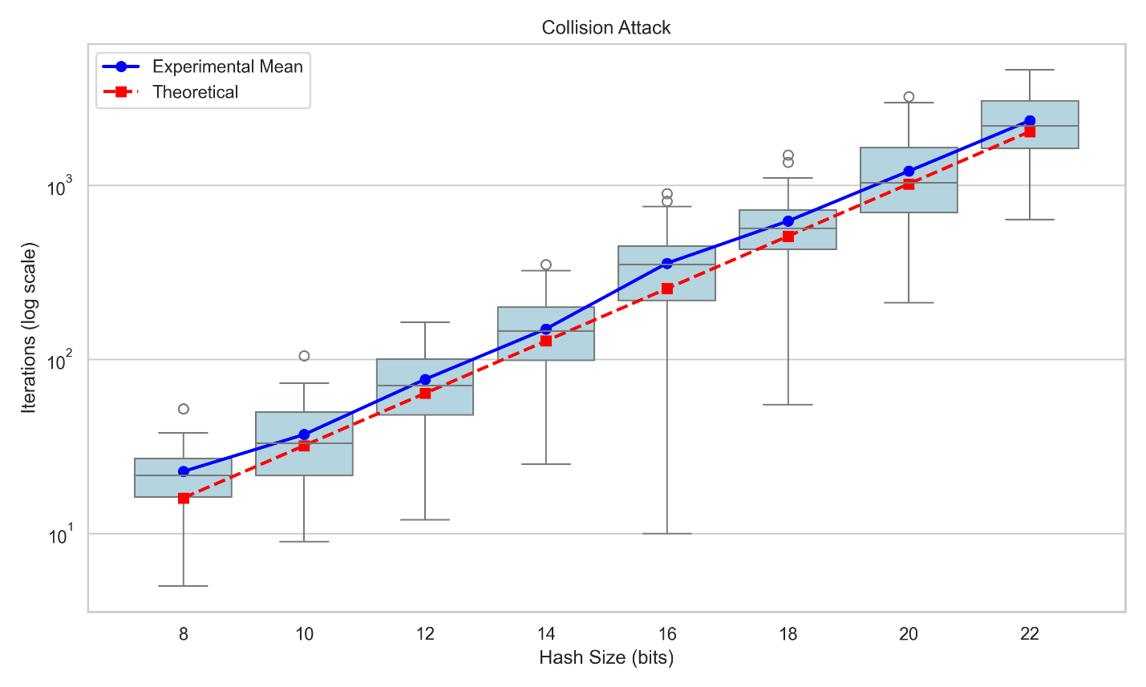

We had similar results with the preimage graph depicted below. With results reflecting the geometric distribution behavior that we can expect from preimage attacks.
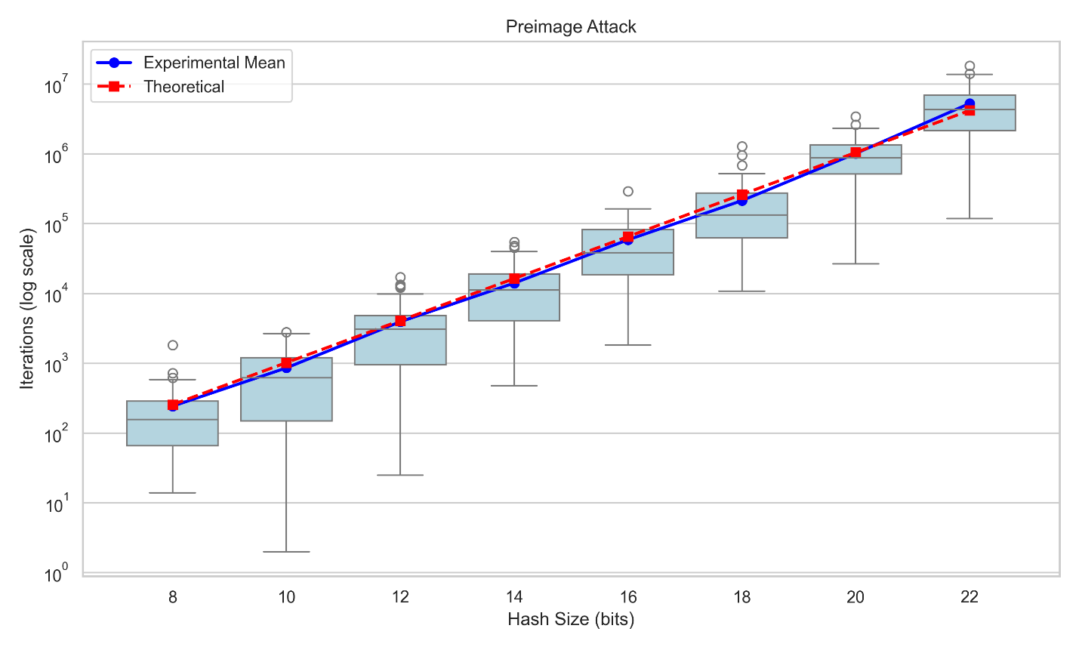

The results of both of these graphs match the expected cost for both the collision and preimage attacks. This shows that collision attacks are much easier than preimage attacks.
This project demonstrates the practicality of attacking truncated SHA-1 hashes. We have confirmed that collision attacks scale as 2 ^ (n/2) while preimage attacks scale as 2^n. The results clearly show that collision attacks require few iterations relative to preimage. Preimage attacks grow exponentially and quickly become computationally expensive.

